Main Function:
Source Code:
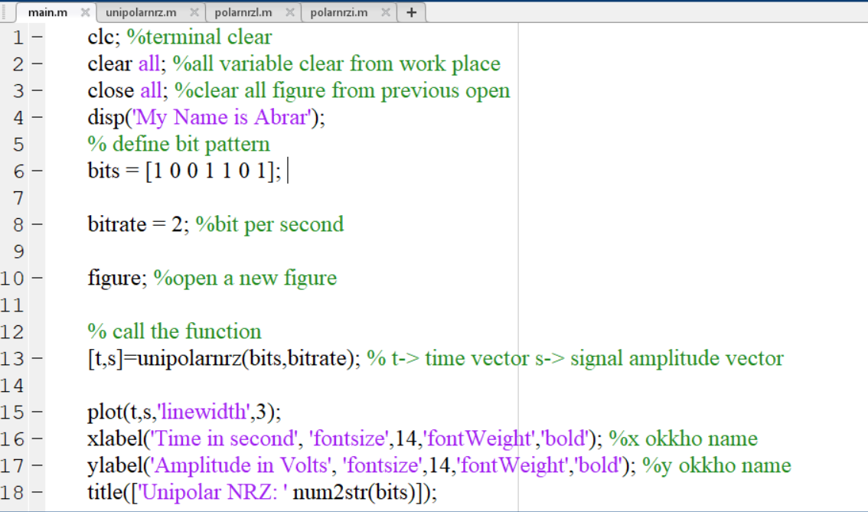
Problem 1: Implementation of AMI Scheme
Source Code:
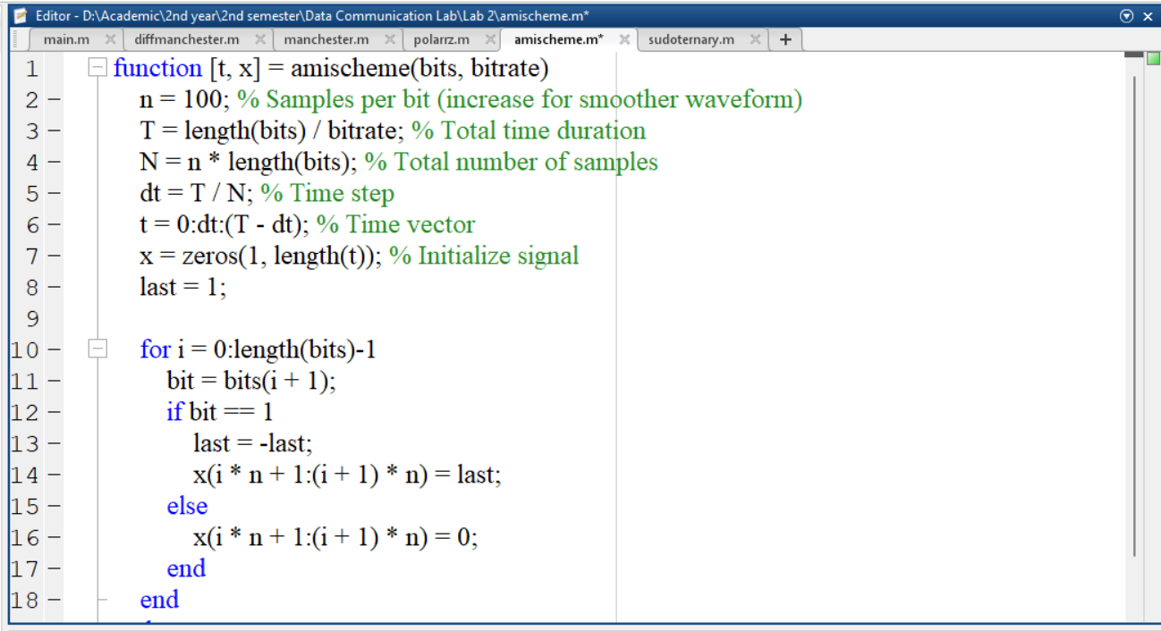

Output:
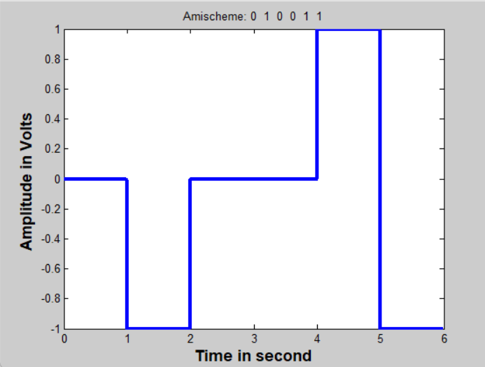
Problem 2: Implementation of Manchester Scheme
Source Code:
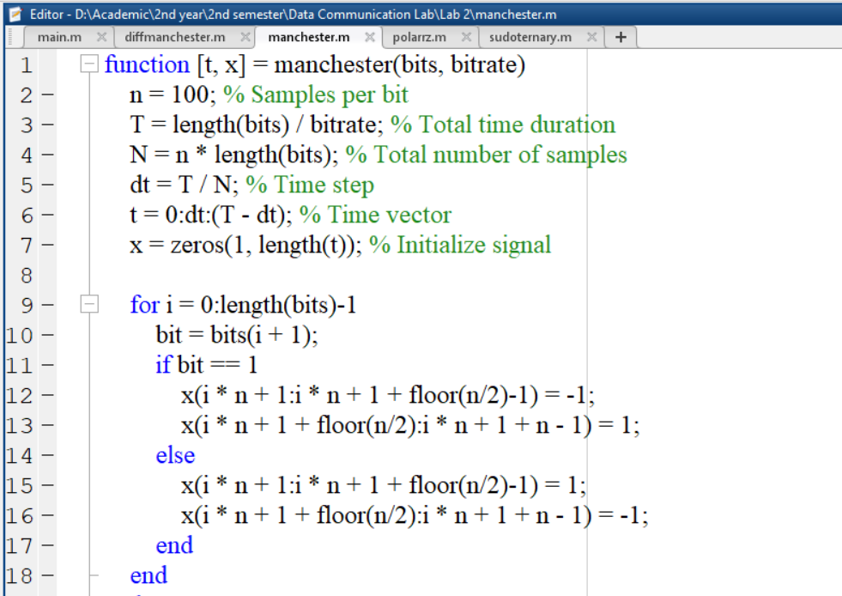
Output:
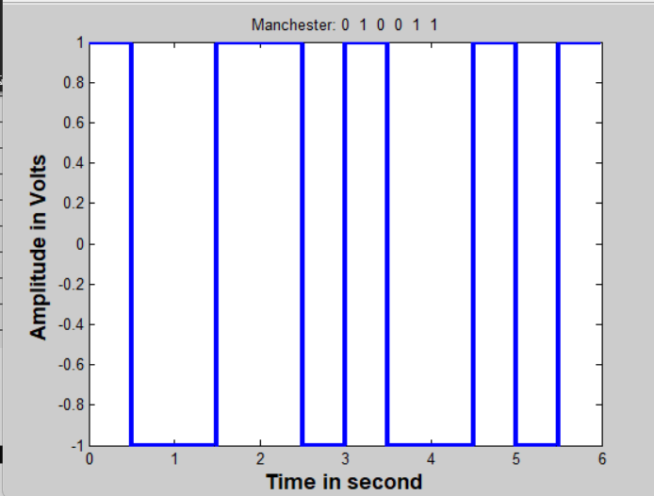
Problem 3: Implementation of Different Manchester Scheme
Source Code:
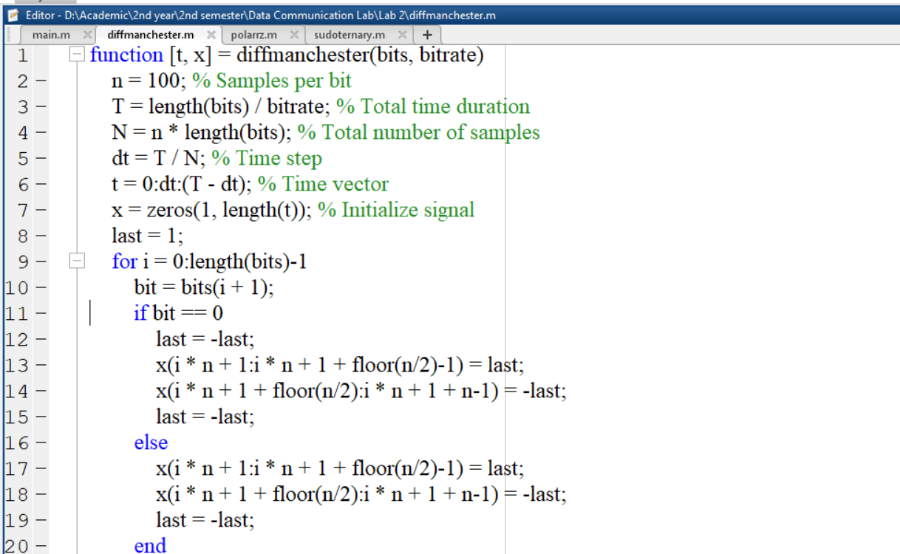
Output:
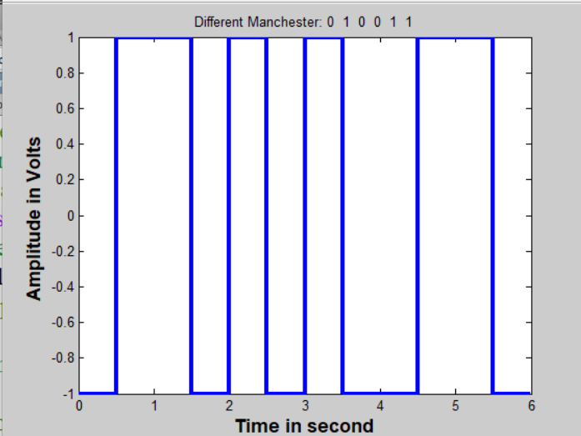
Problem 4: Implementation of Polar Return-to-Zero Scheme
Source Code:
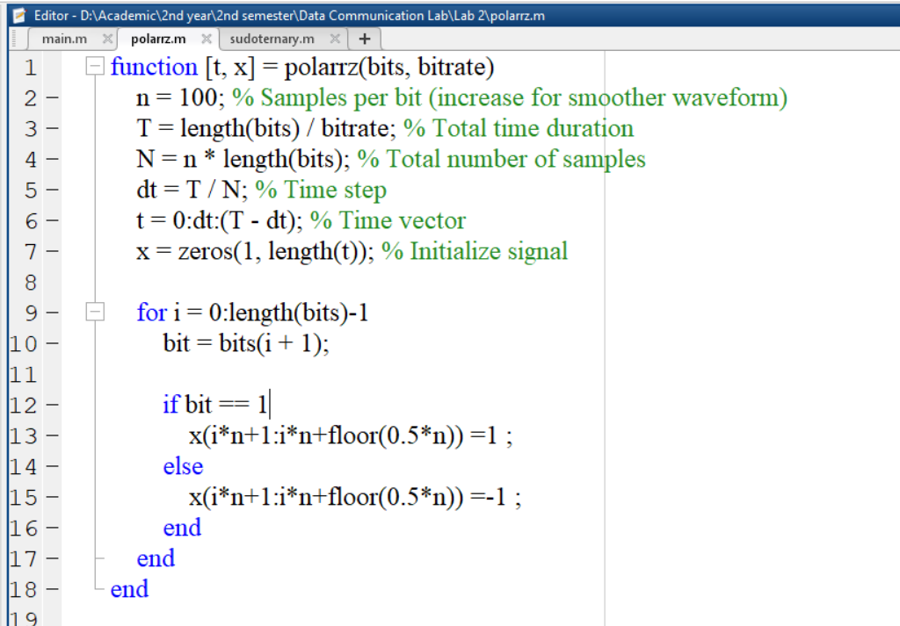
Output:
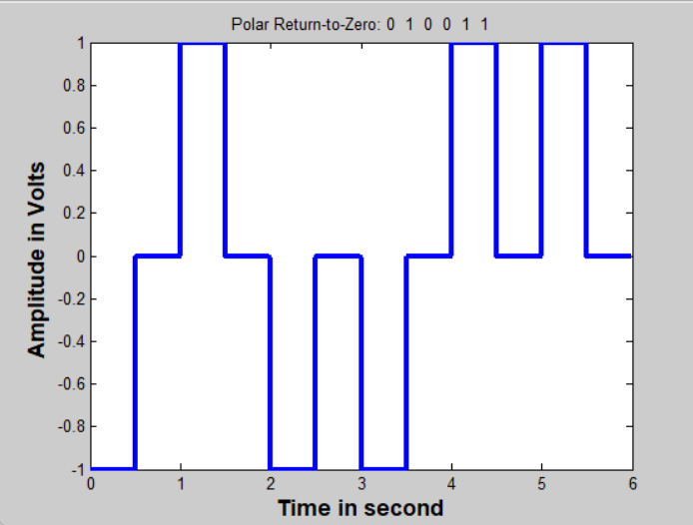
Problem 5: Implementation of Pseudo Ternary Scheme
Source Code:
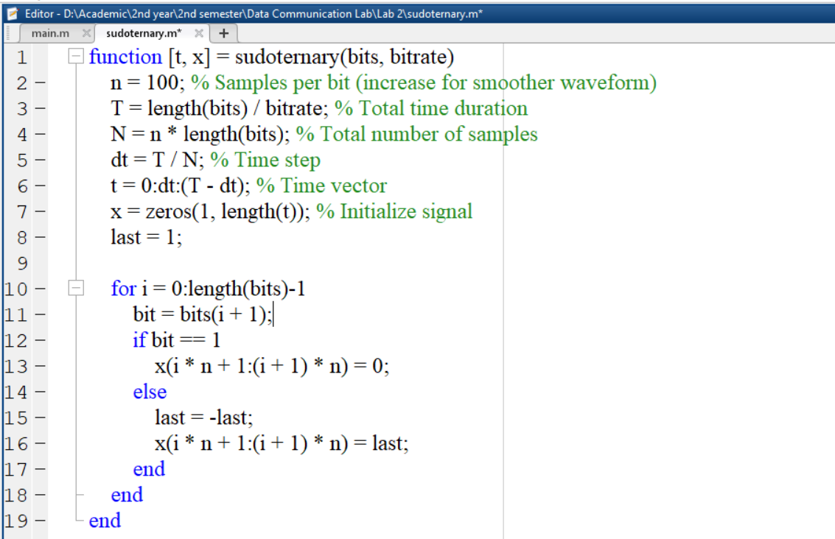
Output:
